Project Planning Phase
Project Planning Template (Product Backlog, Sprint Planning, Stories, Story points)

Date | 25 September 2026
Team ID | 6ab4dd426603573ccfb5912f
Project Name | AI Blog Nest API
Maximum Marks | 5 Marks

Product Backlog, Sprint Schedule, and Estimation (4 Marks)
Use the below template to create product backlog and sprint schedule
Sprint | Functional Requirement (Epic) | User Story Number | User Story / Task | Story Points | Priority | Team Members
Sprint-1 | Authentication | USN-1 | As a new user, I can register with name, email and password. | 3 | High | Mohammed Arbaz S A
Sprint-1 | Authentication | USN-2 | As a user, I can log in with valid email and password. | 3 | High | Sriram P
Sprint-1 | Profile | USN-3 | As an authenticated user, I can view my profile. | 2 | Medium | Hubaidullah H
Sprint-2 | Blog | USN-4 | As an authenticated user, I can create a blog. | 3 | High | Vishnukumar V
Sprint-2 | Blog | USN-5 | As a user, I can view all blogs. | 2 | High | Mohammed Arbaz S A
Sprint-2 | Blog | USN-6 | As a user, I can view one blog by ID. | 2 | Medium | Sriram P
Sprint-2 | Blog | USN-7 | As an author, I can update my own blog. | 3 | High | Hubaidullah H
Sprint-2 | Blog | USN-8 | As an author, I can delete my own blog. | 2 | High | Vishnukumar V
Sprint-3 | AI | USN-9 | As an authenticated user, I can generate a blog from a topic. | 5 | High | Mohammed Arbaz S A
Sprint-3 | AI | USN-10 | As a user, I can summarize blog content. | 3 | High | Sriram p
Sprint-3 | AI | USN-11 | As a user, I can omit a category during generation. | 2 | Medium | Hubaidullah H
Sprint-4 | Quality | — | Validation, middleware and API collection. | 3 | Medium | Vishnukumar V

Project Tracker, Velocity & Burndown Chart: (4 Marks)
Sprint | Total Story Points | Duration | Sprint Start Date | Sprint End Date (Planned) | Story Points Completed (as on Planned End Date) | Sprint Release Date (Actual)
Sprint-1 | 8 | 6 Days
Sprint-2 | 12 | 6 Days
Sprint-3 | 10 | 6 Days
Sprint-4 | 3 | 6 Days

Velocity:
Imagine we have a 10-day sprint duration, and the velocity of the team is 20 (points per sprint). Let’s calculate the team’s average velocity (AV) per iteration unit (story points per day)

AI BlogNest API (planned): the sprint duration is 6 days and the backlog totals 33 story points across four sprints (8, 12, 10 and 3). Planned average velocity = 33 / 4 = 8.25 story points per sprint, i.e. 33 / 24 days ≈ 1.38 story points per day. Actual velocity has not been recorded and must be calculated from completed sprints.
Burndown Chart:
A burn down chart is a graphical representation of work left to do versus time. It is often used in agile software development methodologies such as Scrum. However, burn down charts can be applied to any project containing measurable progress over time.
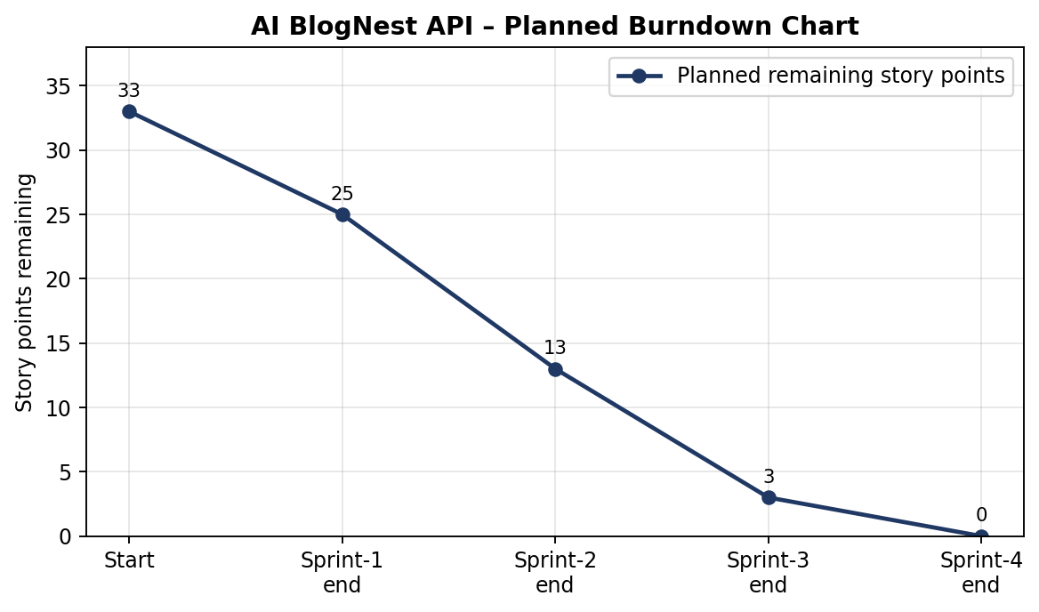
Planned burndown based on the planned story points per sprint (33 → 25 → 13 → 3 → 0). Actual progress against this plan is not recorded.

https://www.visual-paradigm.com/scrum/scrum-burndown-chart/
https://www.atlassian.com/agile/tutorials/burndown-charts

Reference:
https://www.atlassian.com/agile/project-management
https://www.atlassian.com/agile/tutorials/how-to-do-scrum-with-jira-software
https://www.atlassian.com/agile/tutorials/epics
https://www.atlassian.com/agile/tutorials/sprints
https://www.atlassian.com/agile/project-management/estimation
https://www.atlassian.com/agile/tutorials/burndown-charts

